GUI Components
You create graphical user interfaces using GUI objects such as buttons, labels, text fields, check boxes, radio buttons, and combo boxes. Each type of GUI object is defined in a class, such as JButton, JLabel, JTextField, JCheckBox, JRadioButton, and JComboBox. Each GUI component class provides several constructors that you can use to create GUI component objects. The following are examples to create buttons, labels, text fields, check boxes, radio buttons, and combo boxes:
// Create a button with text OK
JButton jbtOK = new JButton("OK");

// Create a label with text "Enter your name: "
JLabel jlblName = new JLabel("Enter your name: ");

// Create a text field with text "Type Name Here"
JTextField jtfName = new JTextField("Type Name Here");

// Create a check box with text bold
JCheckBox jchkBold = new JCheckBox("Bold");

// Create a radio button with text red
JRadioButton jrbRed = new JRadioButton("Red");

// Create a combo box with choices red, green, and blue
JComboBox jcboColor = new JComboBox(new String[]{"Red",
"Green", "Blue"});

The GUI component objects can be displayed.
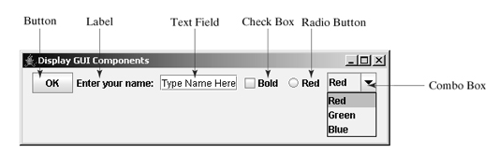

[Page 401]

12.2.1. Swing vs. AWT
Why do the GUI component classes have the prefix J? Instead of JButton, why not name it simply Button? In fact, there is a class already named Button in the java.awt package.
When Java was introduced, the GUI classes were bundled in a library known as the Abstract Windows Toolkit (AWT). For every platform on which Java runs, the AWT components are automatically mapped to the platform-specific components through their respective agents, known as peers. AWT is fine for developing simple graphical user interfaces, but not for developing comprehensive GUI projects. Besides, AWT is prone to platform-specific bugs because its peer-based approach relies heavily on the underlying platform.
With the release of Java 2, the AWT user-interface components were replaced by a more robust, versatile, and flexible library known as Swing components. Swing components are painted directly on canvases using Java code, except for components that are subclasses of java.awt.Window or java.awt.Panel, which must be drawn using native GUI on a specific platform. Swing components are less dependent on the target platform and use less of the native GUI resource. For this reason, Swing components that don't rely on native GUI are referred to as lightweight components, and AWT components are referred to as heavyweight components.
To distinguish new Swing component classes from their AWT counterparts, the names of Swing GUI component classes begin with a prefixed J. Although AWT components are still supported in Java 2, it is better to learn to how program using Swing components, because the AWT user-interface components will eventually fade
A Swing API-based GUI is composed of the following elements:
•Containers – Are on top of the GUI containment hierarchy.
•Components–ContainalltheGUIcomponentsthatare derived from theJComponent class.
•Layout Managers – Are responsible for laying out components in a container.

SwingContainers
Swing containers can be classiﬁed into three main categories:
•Top-level containers: •JFrame,JWindow, andJDialog
•General-purpose containers: •JPanel,JScrollPane,JToolBar,JSplitPane, and JTabbedPane •Special-purpose containers: •JInternalFrame andJLayeredPane

Frames
To create a user interface, you need to create either a frame or an applet to hold the user-interface components.

Creating a Frame
To create a frame, use the JFrame class, as shown in fig.
Frame is a top-level container to hold GUI components.

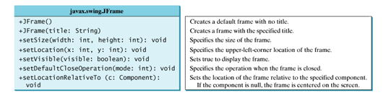

MyFrame.java
1 import javax.swing.*;
2
3 public class MyFrame {
4 public static void main(String[] args) {
5 JFrame frame = new JFrame("MyFrame"); // Create a frame
6 frame.setSize(400, 300); // Set the frame size
7 frame.setLocationRelativeTo(null); // New since JDK 1.4
8 frame.setDefaultCloseOperation(JFrame.EXIT_ON_CLOSE);
9 frame.setVisible(true); // Display the frame
10 }
11 }

The frame is not displayed until the frame.setVisible(true) method is invoked. frame.setSize(400, 300) specifies that the frame is 400 pixels wide and 300 pixels high. If the setSize method is not used, the frame will be sized to display just the title bar. Since the setSize and setVisible methods are both defined in the Component class, they are inherited by the JFrame class.
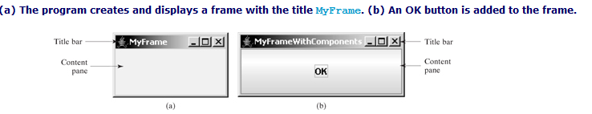
Invoking setLocationRelativeTo(null) (line 7) centers the frame on the screen. Invoking setDefaultCloseOperation(JFrame.EXIT ON CLOSE) (line 8) tells the program to terminate when the frame is closed. If this statement is not used, the program does not terminate when the frame is closed. In that case, you have to stop the program by pressing Ctrl+C at the DOS prompt window in Windows.
Adding Components to a Frame
1 import javax.swing.*;
2
3 public class MyFrameWithComponents {
4 public static void main(String[] args) {
5 JFrame frame = new JFrame("MyFrameWithComponents");
6
7 // Add a button into the frame
8 JButton jbtOK = new JButton("OK");
9 frame.add(jbtOK);
10
11 frame.setSize(400, 300);
12 frame.setDefaultCloseOperation(JFrame.EXIT_ON_CLOSE);
13 frame.setLocationRelativeTo(null); // Center the frame
14 frame.setVisible(true);
15 }
16 }

Layout Managers
The Java GUI components are placed in containers, where they are arranged by the container's layout manager.
Layout manager classes:
•BorderLayout
•FlowLayout
•BoxLayout
•CardLayout
•GridLayout
•GridBagLayout

FlowLayout
FlowLayout is the simplest layout manager. The components are arranged in the container from left to right in the order in which they were added. When one row is filled, a new row is started. You can specify the way the components are aligned by using one of three constants: FlowLayout.RIGHT, FlowLayout.CENTER, or FlowLayout.LEFT.
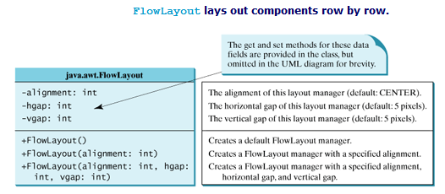

1 import javax.swing.JLabel;
2 import javax.swing.JTextField;
3 import javax.swing.JFrame;
4 import java.awt.FlowLayout;
5
6 public class ShowFlowLayout extends JFrame {
7 public ShowFlowLayout() {
8 // Set FlowLayout, aligned left with horizontal gap 10
9 // and vertical gap 20 between components
10 setLayout (new FlowLayout(FlowLayout.LEFT, 10, 20));
11
12 // Add labels and text fields to the frame
13 add(new JLabel("First Name"));
14 add(new JTextField(8));
15 add(new JLabel("MI"));
16 add(new JTextField(1));
17 add(new JLabel("Last Name"));
18 add(new JTextField(8));
19 }
20
21 /** Main method */
22 public static void main(String[] args) {
23 ShowFlowLayout frame = new ShowFlowLayout();
24 frame.setTitle("ShowFlowLayout");
25 frame.setLocationRelativeTo(null); // Center the frame
26 frame.setDefaultCloseOperation(JFrame.EXIT_ON_CLOSE);
27 frame.setSize(200, 200);
28 frame.setVisible(true);
29 }
30 }

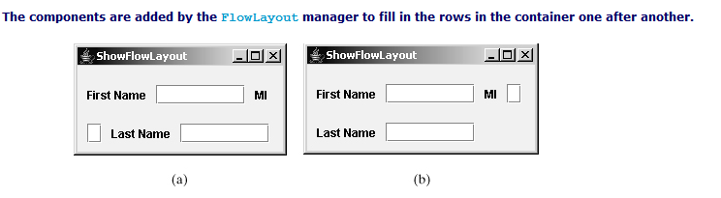

GridLayout
The GridLayout manager arranges components in a grid (matrix) formation with the number of rows and columns defined by the constructor. The components are placed in the grid from left to right, starting with the first row, then the second, and so on, in the order in which they are added. The constructors and methods in GridLayout are
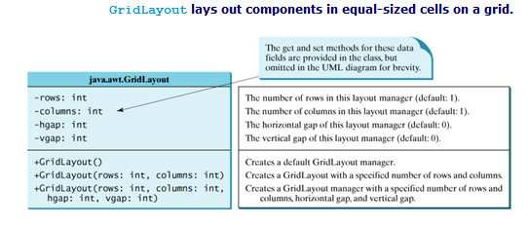

The GridLayout manager divides the container into grids, then the components are added to fill in the cells row by row.
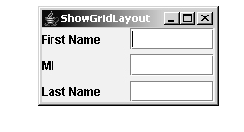
import javax.swing.JLabel;
2 import javax.swing.JTextField;
3 import javax.swing.JFrame;
4 import java.awt.GridLayout;
5
6 public class ShowGridLayout extends JFrame {
7 public ShowGridLayout() {
8 // Set GridLayout, 3 rows, 2 columns, and gaps 5 between
9 // components horizontally and vertically
10 setLayout(new GridLayout(3, 2, 5, 5));
11
12 // Add labels and text fields to the frame
13 add(new JLabel("First Name"));
14 add(new JTextField(8));
15 add(new JLabel("MI"));
16 add(new JTextField(1));
17 add(new JLabel("Last Name"));
18 add(new JTextField(8));
19 }
20
21 /** Main method */
22 public static void main(String[] args) {
23 ShowGridLayout frame = new ShowGridLayout();
24 frame.setTitle("ShowGridLayout");
25 frame.setLocationRelativeTo(null); // Center the frame
26 frame.setDefaultCloseOperation(JFrame.EXIT_ON_CLOSE);
27 frame.setSize(200, 125);
28 frame.setVisible(true);
29 }
30 }

BorderLayout
The BorderLayout manager divides the window into five areas: East, South, West, North, and Center. Components are added to a BorderLayout by using add(Component, index), where index is a constant BorderLayout.EAST, BorderLayout.SOUTH, Border-Layout.WEST, BorderLayout.NORTH, or BorderLayout.CENTER.
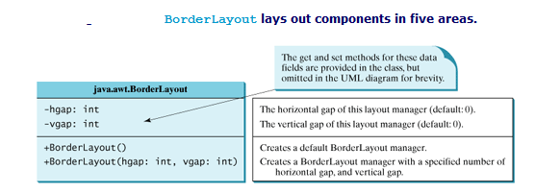
The components are laid out according to their preferred sizes and where they are placed in the container. The North and South components can stretch horizontally; the East and West components can stretch vertically; the Center component can stretch both horizontally and vertically to fill any empty space.
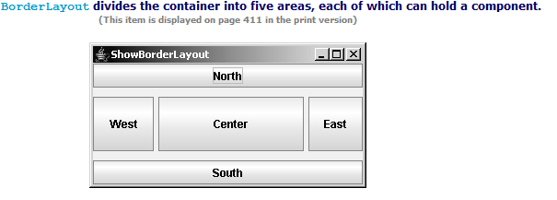
1 import javax.swing.JButton;
2 import javax.swing.JFrame;
3 import java.awt.BorderLayout;
4

[Page 411]
5 public class ShowBorderLayout extends JFrame {
6 public ShowBorderLayout() {
7 // Set BorderLayout with horizontal gap 5 and vertical gap 10
8 setLayout(new BorderLayout(5, 10));
9
10 // Add buttons to the frame
11 add(new JButton("East"), BorderLayout.EAST);
12 add(new JButton("South"), BorderLayout.SOUTH);
13 add(new JButton("West"), BorderLayout.WEST);
14 add(new JButton("North"), BorderLayout.NORTH);
15 add(new JButton("Center"), BorderLayout.CENTER);
16 }
17
18 /** Main method */
19 public static void main(String[] args) {
20 ShowBorderLayout frame = new ShowBorderLayout();
21 frame.setTitle("ShowBorderLayout");
22 frame.setLocationRelativeTo(null); // Center the frame
23 frame.setDefaultCloseOperation(JFrame.EXIT_ON_CLOSE);
24 frame.setSize(300, 200);
25 frame.setVisible(true);
26 }
27 }

TheBoxLayoutManager
TheBoxLayoutmanageraddscomponentsfromlefttoright, and from top to bottom in a single row of column.
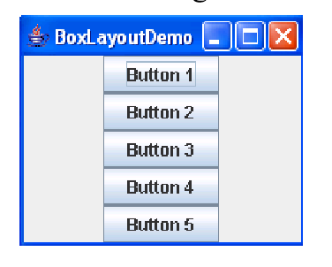
import java.awt.BorderLayout;

import javax.swing.Box;
import javax.swing.JButton;
import javax.swing.JFrame;
import javax.swing.JLabel;
import javax.swing.JTextField;

public class BoxLayoutSample {
public static void main(String args[]) {
JFrame verticalFrame = new JFrame("Vertical");
verticalFrame.setDefaultCloseOperation(JFrame.EXIT_ON_CLOSE);

Box verticalBox = Box.createVerticalBox();
verticalBox.add(new JLabel("Top"));
verticalBox.add(new JTextField("Middle"));
verticalBox.add(new JButton("Bottom"));
verticalFrame.getContentPane().add(verticalBox, BorderLayout.CENTER);
verticalFrame.setSize(150, 150);
verticalFrame.setVisible(true);

JFrame horizontalFrame = new JFrame("Horizontal");

Box horizontalBox = Box.createHorizontalBox();
horizontalBox.add(new JLabel("Left"));
horizontalBox.add(new JTextField("Middle"));
horizontalBox.add(new JButton("Right"));
horizontalFrame.getContentPane()
.add(horizontalBox, BorderLayout.CENTER);
horizontalFrame.setSize(150, 150);
horizontalFrame.setVisible(true);
}
}

TheCardLayoutManager

TheCardLayoutmanagerplacesthecomponentsindifferent cards. Cards are usually controlled by a combo box.
CardLayout places components in the container as cards. Only one card is visible at a time, and the container acts as a stack of cards. The ordering of cards is determined by the container's own internal ordering of its component objects. You can specify the size of the horizontal and vertical gaps surrounding a stack of components in a CardLayout manager.

CardLayout defines a set of methods that allow an application to flip through the cards sequentially or to show a specified card directly

A program that creates two panels in a frame. The first panel uses CardLayout to hold six labels for displaying images. The second panel uses FlowLayout to group four buttons named First, Next, Previous, and Last, and a combo box labeled Image, as shown in Figure

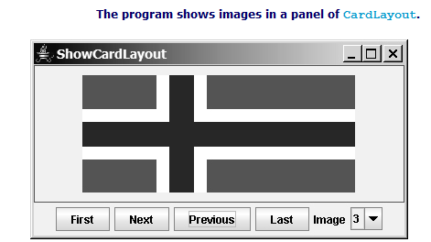

1 import java.awt.*;
2 import java.awt.event.*;
3 import javax.swing.*;
4

[Page 923]
5 public class ShowCardLayout extends JApplet {
6 private CardLayout cardLayout = new CardLayout(20, 10);
7 private JPanel cardPanel = new JPanel(cardLayout) ;
8 private JButton jbtFirst, jbtNext, jbtPrevious, jbtLast;
9 private JComboBox jcboImage;
10 private final int NUM_OF_FLAGS = 6;
11
12 public ShowCardLayout() {
13 cardPanel.setBorder(
14 new javax.swing.border.LineBorder(Color.red));
15
16 // Add 9 labels for displaying images into cardPanel
17 for (int i = 1; i <= NUM_OF_FLAGS; i++) {
18 JLabel label =
19 new JLabel(new ImageIcon("image/flag" + i + ".gif"));
20 cardPanel.add(label, String.valueOf(i));
21 }
22
23 // Panel p to hold buttons and a combo box
24 JPanel p = new JPanel();
25 p.add(jbtFirst = new JButton("First"));
26 p.add(jbtNext = new JButton("Next"));
27 p.add(jbtPrevious= new JButton("Previous"));
28 p.add(jbtLast = new JButton("Last"));
29 p.add(new JLabel("Image"));
30 p.add(jcboImage = new JComboBox());
31
32 // Initialize combo box items
33 for (int i = 1; i <= NUM_OF_FLAGS; i++)
34 jcboImage.addItem(String.valueOf(i));
35
36 // Place panels in the frame
37 add(cardPanel, BorderLayout.CENTER);
38 add(p, BorderLayout.SOUTH);
39
40 // Register listeners with the source objects
41 jbtFirst.addActionListener(new ActionListener() {
42 public void actionPerformed(ActionEvent e) {
43 // Show the first component in cardPanel
44 cardLayout.first(cardPanel);
45 }
46 });
47 jbtNext.addActionListener(new ActionListener() {
48 public void actionPerformed(ActionEvent e) {
49 // Show the first component in cardPanel
50 cardLayout.next(cardPanel);
51 }
52 });
53 jbtPrevious.addActionListener(new ActionListener() {
54 public void actionPerformed(ActionEvent e) {
55 // Show the first component in cardPanel
56 cardLayout.previous(cardPanel);
57 }
58 });
59 jbtLast.addActionListener(new ActionListener() {
60 public void actionPerformed(ActionEvent e) {
61 // Show the first component in cardPanel
62 cardLayout.last(cardPanel);
63 }
64 });

[Page 924]
65 jcboImage.addItemListener(new ItemListener() {
66 public void itemStateChanged(ItemEvent e) {
67 // Show the component at specified index
68 cardLayout.show(cardPanel, (String)e.getItem());
69 }
70 });
71 }
72 }

TheGridBagLayoutManager

TheGridBagLayout manager arranges components in rows and columns, similar to a grid layout, but provides a wide variety of options for resizing and positioning the components.

The Color Class
You can set colors for GUI components by using the java.awt.Color class. Colors are made of red, green, and blue components, each of which is represented by an unsigned byte value that describes its intensity, ranging from 0 (darkest shade) to 255 (lightest shade). This is known as the RGB model.
You can create a color using the following constructor:
public Color(int r, int g, int b);
in which r, g, and b specify a color by its red, green, and blue components. For example,
Color color = new Color(128, 100, 100);

We can use the setBackground(Color c) and setForeground(Color c) methods defined in the java.awt.Component class to set a component's background and foreground colors. Here is an example of setting the background and foreground of a button:
JButton jbtOK = new JButton();
jbtOK.setBackground(color);
jbtOK.setForeground(new Color(100, 1, 1));

Alternatively, you can use one of the thirteen standard colors (black, blue, cyan, darkGray, gray, green, lightGray, magenta, orange, pink, red, white, yellow) defined as constants in java.awt.Color. The following code, for instance, sets the foreground color of a button to red:
jbtOK.setForeground(Color.red);

The Font Class
You can create a font using the java.awt.Font class and set fonts for the components using the setFont method in the Component class.
The constructor for Font is:
public Font(String name, int style, int size);

You can choose a font name from SansSerif, Serif, Monospaced, Dialog, or DialogInput, choose a style from Font.PLAIN (0), Font.BOLD (1), Font.ITALIC (2), and Font.BOLD Font.ITALIC (3), and specify a font size of any positive integer. For example, the following statements create two fonts and set one font to a button:
Font font1 = new Font("SansSerif", Font.BOLD, 16);
Font font2 = new Font("Serif", Font.BOLD + Font.ITALIC, 12);

JButton jbtOK = new JButton("OK");
jbtOK.setFont(font1);

Using Panels as Subcontainers

JPanel p = new JPanel();
p.add(new JButton("OK"));

import javax.swing.*;
import java.awt.*;
public class paneldemo
{
JFrame f;
JPanel p;
paneldemo()
{
f=new JFrame("Swing Frame Demo.....! ");
f.setLayout(null);
p=new JPanel();
p.setBackground(Color.green);
p.setSize(300,300);
p.setVisible(true);
f.add(p);
f.setSize(500,500);
f.setVisible(true);
f.setDefaultCloseOperation(JFrame.EXIT_ON_CLOSE);
}
public static void main(String [] ar)
{
new paneldemo();
}
}
=============================================================================
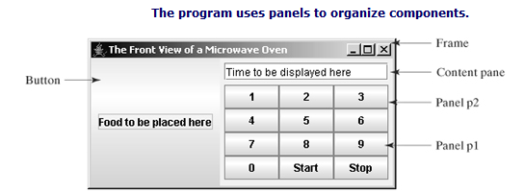

1 import java.awt.*;
2 import javax.swing.*;
3
4 public class TestPanels extends JFrame {
5 public TestPanels() {
6 // Create panel p1 for the buttons and set GridLayout
7 JPanel p1 = new JPanel();
8 p1.setLayout(new GridLayout(4, 3));
9
10 // Add buttons to the panel
11 for (int i = 1; i <= 9; i++) {
12 p1.add(new JButton("" + i));
13 }
14
15 p1.add(new JButton("" + 0));
16 p1.add(new JButton("Start"));
17 p1.add(new JButton("Stop"));
18
19 // Create panel p2 to hold a text field and p1
20 JPanel p2 = new JPanel(new BorderLayout());
21 p2.add (new JTextField("Time to be displayed here"),
22 BorderLayout.NORTH);
23 p2.add (p1, BorderLayout.CENTER);
24
25 // add contents into the frame
26 add(p2, BorderLayout.EAST);
27 add(new JButton("Food to be placed here"),

[Page 415]
28 BorderLayout.CENTER);
29 }
30
31 /** Main method */
32 public static void main(String[] args) {
33 TestPanels frame = new TestPanels();
34 frame.setTitle("The Front View of a Microwave Oven");
35 frame.setLocationRelativeTo(null); // Center the frame
36 frame.setDefaultCloseOperation(JFrame.EXIT_ON_CLOSE);
37 frame.setSize(400, 250);
38 frame.setVisible(true);
39 }
40 }

Image Icons

Java uses the javax.swing.ImageIcon class to represent an icon. An icon is a fixed-size picture; typically it is small and used to decorate components. Images are normally stored in image files. You can use new ImageIcon(filename) to construct an image icon. For example, the following statement creates an icon from an image file us.gif in the image directory under the current class path:
ImageIcon icon = new ImageIcon("image/us.gif");

1 import javax.swing.*;
2 import java.awt.*;
3
4 public class TestImageIcon extends JFrame {
5 private ImageIcon usIcon = new ImageIcon("image/us.gif");
6 private ImageIcon myIcon = new ImageIcon("image/my.jpg");
7 private ImageIcon frIcon = new ImageIcon("image/fr.gif");
8 private ImageIcon ukIcon = new ImageIcon("image/uk.gif");
9
10 public TestImageIcon() {
11 setLayout(new GridLayout(1, 4, 5, 5));
12 add(new JLabel(usIcon));
13 add(new JLabel(myIcon));
14 add(new JButton(frIcon));
15 add(new JButton(ukIcon));
16 }
17
18 /** Main method */
19 public static void main(String[] args) {
20 TestImageIcon frame = new TestImageIcon();
21 frame.setTitle("TestImageIcon");
22 frame.setLocationRelativeTo(null); // Center the frame
23 frame.setDefaultCloseOperation(JFrame.EXIT_ON_CLOSE);
24 frame.setSize(200, 200);
25 frame.setVisible(true);
26 }
27 }

The following statements set an icon in two buttons jbt1 and jbt2:
jbt1.setIcon(icon);
jbt2.setIcon(icon);

Buttons

A button is a component that triggers an action event when clicked. Swing provides regular buttons, toggle buttons, check box buttons, and radio buttons. The common features of these buttons are represented in javax.swing.AbstractButton

private JButton jbtLeft = new JButton(“Submit");

Check Boxes

JCheckBox jchk = new JCheckBox("Student", true);
jchk.setForeground(Color.red);
jchk.setBackground(Color.white);
jchk.setMnemonic('S');

The keyboard mnemonics ‘S’ use a mouse gesture or a shortcut key to select a check box.

Radio Buttons
Radio buttons, also known as option buttons, enable you to choose a single item from a group of choices. In appearance radio buttons resemble check boxes, but check boxes display a square that is either checked or blank, whereas radio buttons display a circle that is either filled (if selected) or blank (if not selected).
JRadioButton inherits AbstractButton and provides several constructors to create radio buttons
JRadioButton jrb = new JRadioButton("Student", true);
jrb.setForeground(Color.red);
jrb.setBackground(Color.white);
jrb.setMnemonic('S');

To group radio buttons, you need to create an instance of java.swing.ButtonGroup and use the add method to add them to it, as follows:
ButtonGroup group = new ButtonGroup();
group.add(jrb1);
group.add(jrb2);

Labels
A label is a display area for a short text, an image, or both. It is often used to label other components (usually text fields).
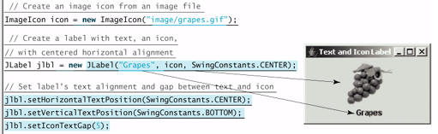

Text Fields
A text field can be used to enter or display a string. JTextField is a subclass of JTextComponent
JTextField inherits JTextComponent, which inherits JComponent. Here is an example of creating a non-editable text field with red foreground color and right horizontal alignment:
JTextField jtfMessage = new JTextField("T-Strom");
jtfMessage.setEditable(false);
jtfMessage.setForeground(Color.red);
jtfMessage.setHorizontalAlignment(SwingConstants.RIGHT);

Text Areas
If you want to let the user enter multiple lines of text, you have to create several instances of JTextField. A better alternative is to use JTextArea, which enables the user to enter multiple lines of text.
JTextArea jtaNote = new JTextArea("This is a text area", 5, 20);
jtaNote.setLineWrap(true);
jtaNote.setWrapStyleWord(true);
jtaNote.setForeground(Color.red);
jtaNote.setFont(new Font("Courier", Font.BOLD, 20));
JTextArea does not handle scrolling, but you can create a JScrollPane object to hold an instance of JTextArea and let JScrollPane handle scrolling for JTextArea, as follows:
// Create a scroll pane to hold text area
JScrollPane scrollPane = new JScrollPane(jta = new JTextArea());
add(scrollPane, BorderLayout.CENTER);
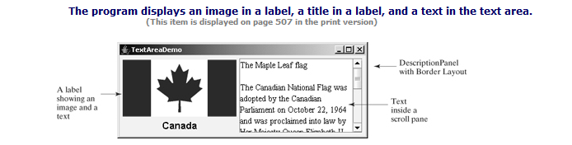
1 import java.awt.*;
2 import javax.swing.*;
3
4 public class TextAreaDemo extends JFrame {
5 // Declare and create a description panel
6 private DescriptionPanel descriptionPanel = new DescriptionPanel();
7
8 public static void main(String[] args) {
9 TextAreaDemo frame = new TextAreaDemo();
10 frame.pack();
11 frame.setLocationRelativeTo(null); // Center the frame
12 frame.setDefaultCloseOperation(JFrame.EXIT_ON_CLOSE);
13 frame.setTitle("TextAreaDemo");
14 frame.setVisible(true);
15 }
16
17 public TextAreaDemo() {
18 // Set title, text and image in the description panel
19 descriptionPanel.setTitle("Canada");
20 String description = "The Maple Leaf flag \n\n" +
21 "The Canadian National Flag was adopted by the Canadian " +
22 "Parliament on October 22, 1964 and was proclaimed into law " +
23 "by Her Majesty Queen Elizabeth II (the Queen of Canada) on " +

[Page 508]
24 "February 15, 1965. The Canadian Flag (colloquially known " +
25 "as The Maple Leaf Flag) is a red flag of the proportions " +
26 "two by length and one by width, containing in its center a " +
27 "white square, with a single red stylized eleven-point " +
28 "mapleleaf centered in the white square.";
29 descriptionPanel.setDescription(description);
30 descriptionPanel.setImageIcon(new ImageIcon("image/ca.gif"));
31
32 // Add the description panel to the frame
33 setLayout(new BorderLayout());
34 add(descriptionPanel, BorderLayout.CENTER);
35 }
36 }
37
38 // Define a panel for displaying image and text
39 class DescriptionPanel extends JPanel {
40 /** Label for displaying an image icon and a text */
41 private JLabel jlblImageTitle = new JLabel();
42
43 /** Text area for displaying text */
44 private JTextArea jtaDescription = new JTextArea();
45
46 public DescriptionPanel() {
47 // Center the icon and text and place the text under the icon
48 jlblImageTitle.setHorizontalAlignment(JLabel.CENTER);
49 jlblImageTitle.setHorizontalTextPosition(JLabel.CENTER);
50 jlblImageTitle.setVerticalTextPosition(JLabel.BOTTOM);
51
52 // Set the font in the label and the text field
53 jlblImageTitle.setFont(new Font("SansSerif", Font.BOLD, 16));
54 jtaDescription.setFont(new Font("Serif", Font.PLAIN, 14));
55
56 // Set lineWrap and wrapStyleWord true for the text area
57 jtaDescription.setLineWrap(true);
58 jtaDescription.setWrapStyleWord(true);
59 jtaDescription.setEditable(false);
60
61 // Create a scroll pane to hold the text area
62 JScrollPane scrollPane = new JScrollPane(jtaDescription);
63
64 // Set BorderLayout for the panel, add label and scrollpane
65 setLayout(new BorderLayout(5, 5));
66 add(scrollPane, BorderLayout.CENTER);
67 add(jlblImageTitle, BorderLayout.WEST);
68 }
69
70 /** Set the title */
71 public void setTitle(String title) {
72 jlblImageTitle.setText(title);
73 }
74
75 /** Set the image icon */
76 public void setImageIcon(ImageIcon icon) {
77 jlblImageTitle.setIcon(icon);
78 }
79
80 /** Set the text description */
81 public void setDescription(String text) {
82 jtaDescription.setText(text);
83 }
84 }
Combo Boxes
A combo box, also known as a choice list or drop-down list, contains a list of items from which the user can choose. It is useful in limiting a user's range of choices and avoids the cumbersome validation of data input.
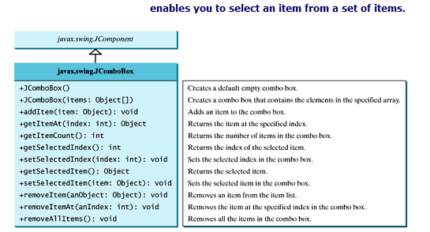
The following statements create a combo box with four items, red foreground, white background, and the second item selected:
JComboBox jcb = new JComboBox(new Object[]
{"Item 1", "Item 2", "Item 3", "Item 4"});
jcb.setForeground(Color.red);
jcb.setBackground(Color.white);
jcb.setSelectedItem("Item 2");

JComboBox can generate ActionEvent and ItemEvent, among many other events. Whenever an item is selected, an ActionEvent is fired. Whenever a new item is selected, JComboBox generates ItemEvent twice, once for deselecting the previously selected item, and the other for selecting the currently selected item. Note that no ItemEvent is fired if the current item is reselected. To respond to an ItemEvent, you need to implement the itemStateChanged(ItemEvent e) handler for processing a choice. To get data from a JComboBox menu, you can use getSelectedItem() to return the currently selected item, or e.getItem() method to get the item from the itemStateChanged(ItemEvent e) handler.
Lists
A list is a component that basically performs the same function as a combo box but enables the user to choose a single value or multiple values. The Swing JList is very versatile.
selectionMode is one of the three values (SINGLE_SELECTION, SINGLE_INTERVAL_SELECTION, MULTIPLE_INTERVAL_SELECTION) defined in javax.swing.SelectionModel that indicate whether a single item, single-interval item, or multiple-interval item can be selected. Single selection allows only one item to be selected. Single-interval selection allows multiple selections, but the selected items must be contiguous. Multiple-interval selection allows selections of multiple contiguous items without restrictions, as shown in Figure 15.24. The default value is MULTIPLE_INTERVAL_SELECTION.
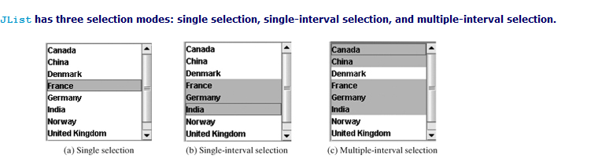
JList jlst = new JList(new Object[]
{"Item 1", "Item 2", "Item 3", "Item 4", "Item 5", "Item 6"});
jlst.setForeground(Color.red);
jlst.setBackground(Color.white);
jlst.setSelectionForeground(Color.pink);
jlst.setSelectionBackground(Color.black);
jlst.setVisibleRowCount(4);
1 import java.awt.*;
2 import javax.swing.*;
3 import javax.swing.event.*;
4
5 public class ListDemo extends JFrame {
6 final int NUMBER_OF_FLAGS = 9;
7
8 // Declare an array of Strings for flag titles
9 private String[] flagTitles = {"Canada", "China", "Denmark",
10 "France", "Germany", "India", "Norway", "United Kingdom",
11 "United States of America"};
12
13 // The list for selecting countries
14 private JList jlst = new JList(flagTitles);
15
16 // Declare an ImageIcon array for the national flags of 9 countries
17 private ImageIcon[] imageIcons = {
18 new ImageIcon("image/ca.gif"),
19 new ImageIcon("image/china.gif"),
20 new ImageIcon("image/denmark.gif"),
21 new ImageIcon("image/fr.gif"),
22 new ImageIcon("image/germany.gif"),
23 new ImageIcon("image/india.gif"),
24 new ImageIcon("image/norway.gif"),
25 new ImageIcon("image/uk.gif"),
26 new ImageIcon("image/us.gif")
27 };
28
29 // Arrays of labels for displaying images
30 private JLabel[] jlblImageViewer = new JLabel[NUMBER_OF_FLAGS];
31
32 public static void main(String[] args) {
33 ListDemo frame = new ListDemo();
34 frame.setSize(650, 500);
35 frame.setTitle("ListDemo");
36 frame.setLocationRelativeTo(null); // Center the frame
37 frame.setDefaultCloseOperation(JFrame.EXIT_ON_CLOSE);
38 frame.setVisible(true);
39 }
40
41 public ListDemo() {
42 // Create a panel to hold nine labels
43 JPanel p = new JPanel(new GridLayout(3, 3, 5, 5));
44
45 for (int i = 0; i < NUMBER_OF_FLAGS; i++) {
46 p.add(jlblImageViewer[i] = new JLabel());
47 jlblImageViewer[i].setHorizontalAlignment
48 (SwingConstants.CENTER);
49 }
50
51 // Add p and the list to the frame
52 add(p, BorderLayout.CENTER);
53 add(new JScrollPane(jlst), BorderLayout.WEST);
54

[Page 515]
55 // Register listeners
56 jlst.addListSelectionListener(new ListSelectionListener() {
57 /** Handle list selection */
58 public void valueChanged(ListSelectionEvent e) {
59 // Get selected indices
60 int[] indices = jlst.getSelectedIndices();
61
62 int i;
63 // Set icons in the labels
64 for (i = 0; i < indices.length; i++) {
65 jlblImageViewer[i].setIcon(imageIcons[indices[i]]);
66 }
67
68 // Remove icons from the rest of the labels
69 for (; i < NUMBER_OF_FLAGS; i++) {
70 jlblImageViewer[i].setIcon(null);
71 }
72 }
73 });
74 }
75 }

Sliders
JSlider is similar to JScrollBar, but JSlider has more properties and can appear in many forms.
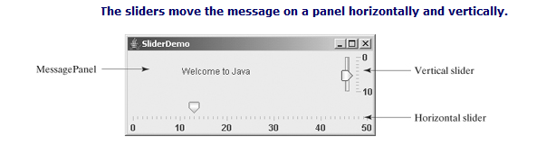
JSlider lets the user graphically select a value by sliding a knob within a bounded interval. The slider can show both major tick marks and minor tick marks between them. The number of pixels between the tick marks is controlled by the majorTickSpacing and minorTickSpacing properties. Sliders can be displayed horizontally or vertically, with or without ticks, and with or without labels.
1 import java.awt.*;
2 import javax.swing.*;
3 import javax.swing.event.*;
4
5 public class SliderDemo extends JFrame {
6 // Create horizontal and vertical sliders
7 private JSlider jsldHort = new JSlider(JSlider.HORIZONTAL);
8 private JSlider jsldVert = new JSlider(JSlider.VERTICAL);
9
10 // Create a MessagePanel
11 private MessagePanel messagePanel =
12 new MessagePanel("Welcome to Java");
13
14 public static void main(String[] args) {
15 SliderDemo frame = new SliderDemo();
16 frame.setTitle("SliderDemo");
17 frame.setLocationRelativeTo(null); // Center the frame
18 frame.setDefaultCloseOperation(JFrame.EXIT_ON_CLOSE);
19 frame.pack();
20 frame.setVisible(true);
21 }
22
23 public SliderDemo() {
24 // Add sliders and message panel to the frame
25 setLayout(new BorderLayout(5, 5));
26 add(messagePanel, BorderLayout.CENTER);
27 add(jsldVert, BorderLayout.EAST);
28 add(jsldHort, BorderLayout.SOUTH);
29
30 // Set properties for sliders
31 jsldHort.setMaximum(50);
32 jsldHort.setPaintLabels(true);
33 jsldHort.setPaintTicks(true);
34 jsldHort.setMajorTickSpacing(10);
35 jsldHort.setMinorTickSpacing(1);
36 jsldHort.setPaintTrack(false);
37 jsldVert.setInverted(true);
38 jsldVert.setMaximum(10);
39 jsldVert.setPaintLabels(true);
40 jsldVert.setPaintTicks(true);
41 jsldVert.setMajorTickSpacing(10);
42 jsldVert.setMinorTickSpacing(1);
43
44 // Register listener for the sliders
45 jsldHort.addChangeListener(new ChangeListener() {
46 /** Handle scroll bar adjustment actions */
47 public void stateChanged(ChangeEvent e) {
48 // getValue() and getMaximumValue() return int, but for better
49 // precision, use double
50 double value = jsldHort.getValue();
51 double maximumValue = jsldHort.getMaximum();
52 double newX = (value * messagePanel.getWidth()
53 / maximumValue);
54 messagePanel.setXCoordinate((int)newX);
55 }
56 });
57 jsldVert.addChangeListener(new ChangeListener() {

[Page 521]
58 /** Handle scroll bar adjustment actions */
59 public void stateChanged(ChangeEvent e) {
60 // getValue() and getMaximumValue() return int, but for better
61 // precision, use double
62 double value = jsldVert.getValue();
63 double maximumValue = jsldVert.getMaximum();
64 double newY = (value * messagePanel.getHeight()
65 / maximumValue);
66 messagePanel.setYCoordinate((int)newY);
67 }
68 });
69 }
70 }

JTabbedPane
JTabbedPane is a useful Swing container that provides a set of mutually exclusive tabs for accessing multiple components,
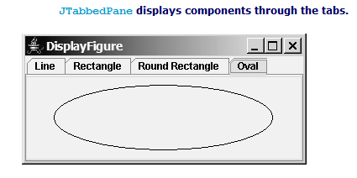

1 import java.awt.*;
2 import javax.swing.*;
3
4 public class DisplayFigure extends JApplet {
5 private JTabbedPane jtpFigures = new JTabbedPane();
6 private FigurePanel squarePanel = new FigurePanel();
7 private FigurePanel rectanglePanel = new FigurePanel();
8 private FigurePanel circlePanel = new FigurePanel();
9 private FigurePanel ovalPanel = new FigurePanel();
10
11 public DisplayFigure() {
12 squarePanel.setType(FigurePanel.LINE);
13 rectanglePanel.setType(FigurePanel.RECTANGLE);
14 circlePanel.setType(FigurePanel.ROUND_RECTANGLE);
15 ovalPanel.setType(FigurePanel.OVAL);
16
17 add(jtpFigures, BorderLayout.CENTER);
18 jtpFigures.add(squarePanel, "Line");
19 jtpFigures.add(rectanglePanel, "Rectangle");
20 jtpFigures.add(circlePanel, "Round Rectangle");
21 jtpFigures.add(ovalPanel, "Oval");
22
23 jtpFigures.setToolTipTextAt(0, "Line");
24 jtpFigures.setToolTipTextAt(1, "Rectangle");
25 jtpFigures.setToolTipTextAt(2, "Round Rectangle");
26 jtpFigures.setToolTipTextAt(3, "Oval");
27 }
28 }

import javax.swing.*;
import java.awt.*;
import java.awt.event.*;
public class TabPanel extends JFrame
{
Container container;
JTabbedPane tpane;
JPanel red = new JPanel();
JPanel green = new JPanel();
JPanel blue = new JPanel();
public TabPanel()
{
super("Tabbed Panel");
red.setBackground(Color.red);
green.setBackground(Color.green);
blue.setBackground(Color.blue);
container = getContentPane();
JPanel jpanel = new JPanel(new GridLayout(1, 1));

tpane = new JTabbedPane();
tpane.addTab("RED", red);
tpane.addTab("BLUE", blue);
tpane.addTab("GREEN", green);
//tpane.setSelectedIndex(0);
jpanel.add(tpane);
container.add(jpanel);
setSize(350,400);
setVisible(true);
}
/* Creating an instance of JPanel. */
void makePane(String myString)
{
JPanel myPanel = new JPanel();
}
public static void main(String args[])
{

try
{
for (javax.swing.UIManager.LookAndFeelInfo info : javax.swing.UIManager.getInstalledLookAndFeels())
{

if ("Nimbus".equals(info.getName()))
{

javax.swing.UIManager.setLookAndFeel(info.getClassName());

break;

}

}

}
catch(Exception e)
{
e.printStackTrace();
}
TabPanel tabpanel = new TabPanel();
}
}

JSplitPane
JSplitPane is a convenient Swing container that contains two components with a separate bar known as a divide.
The bar can divide the container horizontally or vertically, and can be dragged to change the amount of space occupied by each component.
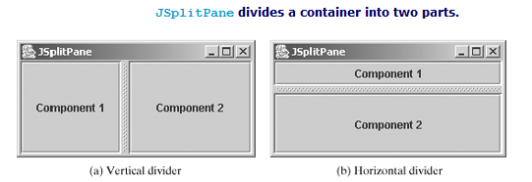

Swing Borders
Swing provides a variety of borders that you can use to decorate components.
A Swing border is defined in the Border interface. Every instance of JComponent can set a border through the border property defined in JComponent. If a border is present, it replaces the inset. The AbstractBorder class implements an empty border with no size. This provides a convenient base class from which other border classes can easily be derived. There are eight concrete border classes, BevelBorder, SoftBevelBorder, CompoundBorder, EmptyBorder, EtchedBorder, LineBorder, MatteBorder, and TitledBorder,

- BevelBorder is a 3D-look border that can be lowered or raised. BevelBorder has the following constructors, which create a BevelBorder with the specified bevelType (BevelBorder.LOWERED or BevelBorder.RAISED) and colors:
- BevelBorder(int bevelType)
- BevelBorder(int bevelType, Color highlight, Color shadow)
- BevelBorder(int bevelType, Color highlightOuterColor,
- Color highlightInnerColor, Color shadowOuterColor,
- Color shadowInnerColor)
- SoftBevelBorder is a raised or lowered bevel with softened corners. SoftBevelBorder has the following constructors:
- SoftBevelBorder(int bevelType)
- SoftBevelBorder(int bevelType, Color highlight, Color shadow)
- SoftBevelBorder(int bevelType, Color highlightOuterColor,
- Color highlightInnerColor, Color
- shadowOuterColor, Color shadowInnerColor)
- EmptyBorder is a border with border space but no drawings. EmptyBorder has the following constructors:
- EmptyBorder(Insets borderInsets)
- EmptyBorder(int top, int left, int bottom, int right)
- EtchedBorder is an etched border that can be etched-in or etched-out. EtchedBorder has the property etchType with the value LOWERED or RAISED. EtchedBorder has the following constructors:
- EtchedBorder() // default constructor with a lowered border
- EtchedBorder(Color highlight, Color shadow)
- EtchedBorder(int etchType)
- EtchedBorder(int etchType, Color highlight, Color shadow)
- LineBorder draws a line of arbitrary thickness and a single color around the border. LineBorder has the following constructors:
- LineBorder(Color color) // Thickness 1
- LineBorder(Color color, int thickness)
- LineBorder(Color color, int thickness, boolean roundedCorners)
- MatteBorder is a matte-like border padded with the icon images. MatteBorder has the following constructors:
- MatteBorder(Icon tileIcon)
- MatteBorder(Insets borderInsets, Color matteColor)
- MatteBorder(Insets borderInsets, Icon tileIcon)
- MatteBorder(int top, int left, int bottom, int right,
- Color matteColor)
- MatteBorder(int top, int left, int bottom, int right, Icon
- tileIcon)
- CompoundBorder is used to compose two Border objects into a single border by nesting an inside Border object within the insets of an outside Border object using the following constructor:
- CompoundBorder(Border outsideBorder, Border insideBorder)
- TitledBorder is a border with a string title in a specified position. Titled border can be composed with other borders. TitledBorder has the following constructors:
- TitledBorder(String title)
- TitledBorder(Border border) // Empty title on another border
- TitledBorder(Border border, String title)
- TitledBorder(Border border, String title,
- int titleJustification, int titlePosition)
- TitledBorder(Border border, String title,
- int titleJustification, int titlePosition,
- Font titleFont)
- TitledBorder(Border border, String title, int
- titleJustification, int titlePosition,
- Font titleFont, Color titleColor)
For convenience, Java also provides the javax.swing.BorderFactory class, which contains the static methods for creating bo

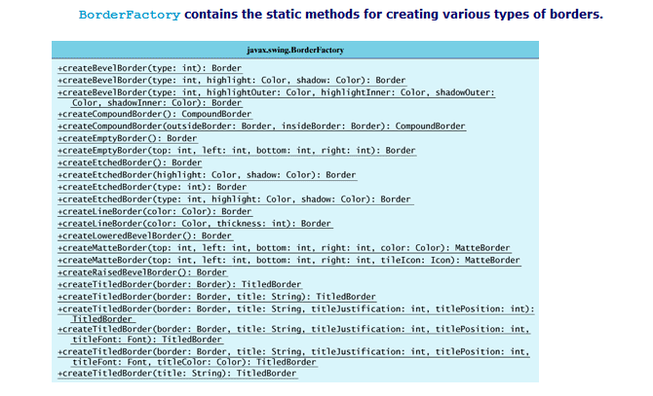

For example, to create an etched border, use the following statement:
Border border = BorderFactory.createEtchedBorder();

1 import java.awt.*;
2 import java.awt.event.ActionListener;
3 import java.awt.event.ActionEvent;
4 import javax.swing.*;
5 import javax.swing.border.*;
6
7 public class BorderDemo extends JApplet {
8 // Declare a label for displaying message
9 private JLabel jLabel1 = new JLabel("Display the border type",
10 JLabel.CENTER);
11
12 // A check box for selecting a border with or without a title
13 private JCheckBox jchkTitled;
14
15 // Radio buttons for border styles
16 private JRadioButton jrbLoweredBevel, jrbRaisedBevel,
17 jrbEtched, jrbLine, jrbMatte, jrbEmpty;
18
19 // Radio buttons for titled border options
20 private JRadioButton jrbAboveBottom, jrbBottom,
21 jrbBelowBottom, jrbAboveTop, jrbTop, jrbBelowTop,
22 jrbLeft, jrbCenter, jrbRight;
23
24 // TitledBorder for the label
25 private TitledBorder jLabel1Border;
26
27 /** Constructor */
28 public BorderDemo() {
29 // Create a JLabel instance and set colors
30 jLabel1.setBackground(Color.yellow);
31 jLabel1.setBorder(jLabel1Border);
32
33 // Place title position radio buttons
34 JPanel jpPosition = new JPanel();
35 jpPosition.setLayout(new GridLayout(3, 2));
36 jpPosition.add(
37 jrbAboveBottom = new JRadioButton("ABOVE_BOTTOM"));
38 jpPosition.add(jrbAboveTop = new JRadioButton("ABOVE_TOP"));
39 jpPosition.add(jrbBottom = new JRadioButton("BOTTOM"));
40 jpPosition.add(jrbTop = new JRadioButton("TOP"));
41 jpPosition.add(
42 jrbBelowBottom = new JRadioButton("BELOW_BOTTOM"));
43 jpPosition.add(jrbBelowTop = new JRadioButton("BELOW_TOP"));
44 jpPosition.setBorder(new TitledBorder("Position"));
45
46 // Place title justification radio buttons
47 JPanel jpJustification = new JPanel();
48 jpJustification.setLayout(new GridLayout(3,1));
49 jpJustification.add(jrbLeft = new JRadioButton("LEFT"));
50 jpJustification.add(jrbCenter = new JRadioButton("CENTER"));
51 jpJustification.add(jrbRight = new JRadioButton("RIGHT"));
52 jpJustification.setBorder(new TitledBorder("Justification"));
53
54 // Create panel jpTitleOptions to hold jpPosition and
55 // jpJustification
56 JPanel jpTitleOptions = new JPanel();
57 jpTitleOptions.setLayout(new BorderLayout());

[Page 957]
58 jpTitleOptions.add(jpPosition, BorderLayout.CENTER);
59 jpTitleOptions.add(jpJustification, BorderLayout.EAST);
60
61 // Create Panel jpTitle to hold a check box and title position
62 // radio buttons, and title justification radio buttons
63 JPanel jpTitle = new JPanel();
64 jpTitle.setBorder(new TitledBorder("Border Title"));
65 jpTitle.setLayout(new BorderLayout());
66 jpTitle.add(jchkTitled = new JCheckBox("Titled"),
67 BorderLayout.NORTH);
68 jpTitle.add(jpTitleOptions, BorderLayout.CENTER);
69
70 // Group radio buttons for title position
71 ButtonGroup btgTitlePosition = new ButtonGroup();
72 btgTitlePosition.add(jrbAboveBottom);
73 btgTitlePosition.add(jrbBottom);
74 btgTitlePosition.add(jrbBelowBottom);
75 btgTitlePosition.add(jrbAboveTop);
76 btgTitlePosition.add(jrbTop);
77 btgTitlePosition.add(jrbBelowTop);
78
79 // Group radio buttons for title justification
80 ButtonGroup btgTitleJustification = new ButtonGroup();
81 btgTitleJustification.add(jrbLeft);
82 btgTitleJustification.add(jrbCenter);
83 btgTitleJustification.add(jrbRight);
84
85 // Create Panel jpBorderStyle to hold border style radio buttons
86 JPanel jpBorderStyle = new JPanel();
87 jpBorderStyle.setBorder(new TitledBorder("Border Style"));
88 jpBorderStyle.setLayout(new GridLayout(6, 1));
89 jpBorderStyle.add(jrbLoweredBevel =
90 new JRadioButton("Lowered Bevel"));
91 jpBorderStyle.add(jrbRaisedBevel =
92 new JRadioButton("Raised Bevel"));
93 jpBorderStyle.add(jrbEtched = new JRadioButton("Etched"));
94 jpBorderStyle.add(jrbLine = new JRadioButton("Line"));
95 jpBorderStyle.add(jrbMatte = new JRadioButton("Matte"));
96 jpBorderStyle.add(jrbEmpty = new JRadioButton("Empty"));
97
98 // Group radio buttons for border styles
99 ButtonGroup btgBorderStyle = new ButtonGroup();
100 btgBorderStyle.add(jrbLoweredBevel);
101 btgBorderStyle.add(jrbRaisedBevel);
102 btgBorderStyle.add(jrbEtched);
103 btgBorderStyle.add(jrbLine);
104 btgBorderStyle.add(jrbMatte);
105 btgBorderStyle.add(jrbEmpty);
106
107 // Create Panel jpAllChoices to place jpTitle and jpBorderStyle
108 JPanel jpAllChoices = new JPanel();
109 jpAllChoices.setLayout(new BorderLayout());
110 jpAllChoices.add(jpTitle, BorderLayout.CENTER);
111 jpAllChoices.add(jpBorderStyle, BorderLayout.EAST);
112
113 // Place panels in the frame
114 setLayout(new BorderLayout());
115 add(jLabel1, BorderLayout.CENTER);
116 add(jpAllChoices, BorderLayout.SOUTH);
117

[Page 958]
118 // Register listeners
119 ActionListener listener = new EventListener();
120 jchkTitled.addActionListener(listener);
121 jrbAboveBottom.addActionListener(listener);
122 jrbBottom.addActionListener(listener);
123 jrbBelowBottom.addActionListener(listener);
124 jrbAboveTop.addActionListener(listener);
125 jrbTop.addActionListener(listener);
126 jrbBelowTop.addActionListener(listener);
127 jrbLeft.addActionListener(listener);
128 jrbCenter.addActionListener(listener);
129 jrbRight.addActionListener(listener);
130 jrbLoweredBevel.addActionListener(listener);
131 jrbRaisedBevel.addActionListener(listener);
132 jrbLine.addActionListener(listener);
133 jrbEtched.addActionListener(listener);
134 jrbMatte.addActionListener(listener);
135 jrbEmpty.addActionListener(listener);
136 }
137
138 private class EventListener implements ActionListener {
139 /** Handle ActionEvents on check box and radio buttons */
140 public void actionPerformed(ActionEvent e) {
141 // Get border style
142 Border border = new EmptyBorder (2,2,2,2);
143
144 if (jrbLoweredBevel.isSelected()) {
145 border = new BevelBorder(BevelBorder.LOWERED);
146 jLabel1.setText("Lowered Bevel Style");
147 }
148 else if (jrbRaisedBevel.isSelected()) {
149 border = new BevelBorder(BevelBorder.RAISED);
150 jLabel1.setText("Raised Bevel Style");
151 }
152 else if (jrbEtched.isSelected()) {
153 border = new EtchedBorder();
154 jLabel1.setText("Etched Style");
155 }
156 else if (jrbLine.isSelected()) {
157 border = new LineBorder(Color.black, 5);
158 jLabel1.setText("Line Style");
159 }
160 else if (jrbMatte.isSelected()) {
161 border = new MatteBorder(15, 15, 15, 15,
162 new imageIcon(getClass().getResource("image/caIcon.gif")));
163 jLabel1.setText("Matte Style");
164 }
165 else if (jrbEmpty.isSelected()) {
166 border = new EmptyBorder(2, 2, 2, 2);
167 jLabel1.setText("Empty Style");
168 }
169
170 if (jchkTitled.isSelected()) {
171 // Get the title position and justification
172 int titlePosition = TitledBorder.DEFAULT_POSITION;
173 int titleJustification = TitledBorder.DEFAULT_JUSTIFICATION;
174
175 if (jrbAboveBottom.isSelected())
176 titlePosition = TitledBorder.ABOVE_BOTTOM;
177 else if (jrbBottom.isSelected())

[Page 959]
178 titlePosition = TitledBorder.BOTTOM;
179 else if (jrbBelowBottom.isSelected())
180 titlePosition = TitledBorder.BELOW_BOTTOM;
181 else if (jrbAboveTop.isSelected())
182 titlePosition = TitledBorder.ABOVE_TOP;
183 else if (jrbTop.isSelected())
184 titlePosition = TitledBorder.TOP;
185 else if (jrbBelowTop.isSelected())
186 titlePosition = TitledBorder.BELOW_TOP;
187
188 if (jrbLeft.isSelected())
189 titleJustification = TitledBorder.LEFT;
190 else if (jrbCenter.isSelected())
191 titleJustification = TitledBorder.CENTER;
192 else if (jrbRight.isSelected())
193 titleJustification = TitledBorder.RIGHT;
194
195 jLabel1Border = new TitledBorder("A Title");
196 jLabel1Border.setBorder(border);
197 jLabel1Border.setTitlePosition(titlePosition);
198 jLabel1Border.setTitleJustification(titleJustification);
199 jLabel1.setBorder(jLabel1Border);
200 }
201 else {
202 jLabel1.setBorder(border);
203 }
204 }
205 }
206 }

1 import java.awt.*;
2 import javax.swing.*;
3 import javax.swing.border.*;
4
5 public class TestSwingCommonFeatures extends JFrame {
6 public TestSwingCommonFeatures() {
7 // Create a panel to group three buttons
8 JPanel p1 = new JPanel(new FlowLayout(FlowLayout.LEFT, 2, 2));
9 JButton jbtLeft = new JButton("Left");
10 JButton jbtCenter = new JButton("Center");
11 JButton jbtRight = new JButton("Right");
12 jbtLeft.setBackground(Color.WHITE);
13 jbtCenter.setForeground(Color.GREEN);
14 jbtRight.setToolTipText("This is the Right button");
15 p1.add(jbtLeft);
16 p1.add(jbtCenter);
17 p1.add(jbtRight);
18 p1.setBorder(new TitledBorder("Three Buttons"));

[Page 417]
19
20 // Create a font and a line border
21 Font largeFont = new Font("TimesRoman", Font.BOLD, 20);
22 Border lineBorder = new LineBorder(Color.BLACK, 2);
23
24 // Create a panel to group two labels
25 JPanel p2 = new JPanel(new GridLayout(1, 2, 5, 5));
26 JLabel jlblRed = new JLabel("Red");
27 JLabel jlblOrange = new JLabel("Orange");
28 jlblRed.setForeground(Color.RED);
29 jlblOrange.setForeground(Color.ORANGE);
30 jlblRed.setFont(largeFont);
31 jlblOrange.setFont(largeFont);
32 jlblRed.setBorder(lineBorder);
33 jlblOrange.setBorder(lineBorder);
34 p2.add(jlblRed);
35 p2.add(jlblOrange);
36 p2.setBorder(new TitledBorder("Two Labels"));
37
38 // Add two panels to the frame
39 setLayout(new GridLayout(2, 1, 5, 5));
40 add(p1);
41 add(p2);
42 }
43
44 public static void main(String[] args) {
45 // Create a frame and set its properties
46 JFrame frame = new TestSwingCommonFeatures();
47 frame.setTitle("TestSwingCommonFeatures");
48 frame.setSize(300, 150);
49 frame.setLocationRelativeTo(null); // Center the frame
50 frame.setDefaultCloseOperation(JFrame.EXIT_ON_CLOSE);
51 frame.setVisible(true);
52 }
53 }

Menus
Menus make selection easier and are widely used in window applications. Java provides five classes that implement menus: JMenuBar, JMenu, JMenuItem, JCheckBoxMenuItem, and JRadioButtonMenuItem.
JMenuBar is a top-level menu component used to hold menus. A menu consists of menu items that the user can select (or toggle on or off). A menu item can be an instance of JMenuItem, JCheckBoxMenuItem, or JRadioButtonMenuItem. Menu items can be associated with icons, keyboard mnemonics, and keyboard accelerators. Menu items can be separated using separators.

Creating Menus
The sequence of implementing menus in Java is as follows:
- Create a menu bar and associate it with a frame or an applet by using the setJMenuBar method. For example, the following code creates a frame and a menu bar, and sets the menu bar in the frame:
- JFrame frame = new JFrame();
- frame.setSize(300, 200);
- frame.setVisible(true);
- JMenuBar jmb = new JMenuBar();
- frame.setJMenuBar(jmb); // Attach a menu bar to a frame
- Create menus and associate them with the menu bar. You can use the following constructor to create a menu:
- public JMenu(String label)
Here is an example of creating menus:
JMenu fileMenu = new JMenu("File");
JMenu helpMenu = new JMenu("Help");
This creates two menus labeled File and Help. The menus will not be seen until they are added to an instance of JMenuBar, as follows:
jmb.add(fileMenu);
jmb.add(helpMenu);
- Create menu items and add them to the menus.
- fileMenu.add(new JMenuItem("New"));
- fileMenu.add(new JMenuItem("Open"));
- fileMenu.addSeparator();
- fileMenu.add(new JMenuItem("Print"));
- fileMenu.addSeparator();
- fileMenu.add(new JMenuItem("Exit"));
This code adds the menu items New, Open, a separator bar, Print, another separator bar, and Exit, in this order, to the File menu. The addSeparator() method adds a separator bar in the menu.
Creating submenu items. You can also embed menus inside menus so that the embedded menus become submenus. Here is an example:
JMenu softwareHelpSubMenu = new JMenu("Software");
JMenu hardwareHelpSubMenu = new JMenu("Hardware");
helpMenu.add(softwareHelpSubMenu);
helpMenu.add(hardwareHelpSubMenu);
softwareHelpSubMenu.add(new JMenuItem("Unix"));
softwareHelpSubMenu.add(new JMenuItem("NT"));
softwareHelpSubMenu.add(new JMenuItem("Win95"));
This code adds two submenus, softwareHelpSubMenu and hardwareHelpSubMenu, in helpMenu. The menu items Unix, NT, and Win95 are added to softwareHelpSubMenu
Creating check box menu items. You can also add a JCheckBoxMenuItem to a JMenu. JCheckBoxMenuItem is a subclass of JMenuItem that adds a Boolean state to the JMenuItem, and displays a check when its state is true. You can click a menu item to turn it on or off. For example, the following statement adds the check box menu item Check it
helpMenu.add(new JCheckBoxMenuItem("Check it"));

Creating radio button menu items. You can also add radio buttons to a menu, using the JRadioButtonMenuItem class. This is often useful when you have a group of mutually exclusive choices in the menu. For example, the following statements add a submenu named Color and a set of radio buttons for choosing a color (see Figure 29.2(b)):
JMenu colorHelpSubMenu = new JMenu("Color");
helpMenu.add(colorHelpSubMenu);
JRadioButtonMenuItem jrbmiBlue, jrbmiYellow, jrbmiRed;
colorHelpSubMenu.add(jrbmiBlue =
new JRadioButtonMenuItem("Blue"));
colorHelpSubMenu.add(jrbmiYellow =
new JRadioButtonMenuItem("Yellow"));
colorHelpSubMenu.add(jrbmiRed =
new JRadioButtonMenuItem("Red"));

ButtonGroup btg = new ButtonGroup();
btg.add(jrbmiBlue);
btg.add(jrbmiYellow);
btg.add(jrbmiRed);

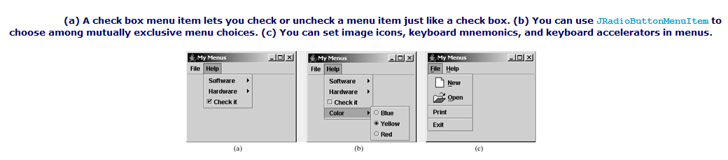

Image Icons, Keyboard Mnemonics, and Keyboard Accelerators
The menu components JMenu, JMenuItem, JCheckBoxMenuItem, and JRadioButtonMenuItem have the icon and mnemonic properties. For example, using the following code, you can set icons for the New and Open menu items, and set keyboard mnemonics for File, Help, New, and Open:
JMenuItem jmiNew, jmiOpen;
fileMenu.add(jmiNew = new JMenuItem("New"));
fileMenu.add(jmiOpen = new JMenuItem("Open"));
jmiNew.setIcon(new ImageIcon("image/new.gif"));
jmiOpen.setIcon(new ImageIcon("image/open.gif"));
helpMenu.setMnemonic('H');
fileMenu.setMnemonic('F');
jmiNew.setMnemonic('N');
jmiOpen.setMnemonic('O');
By default, the text is at the right of the icon. Use setHorizontalTextPosition(SwingConstants.LEFT) to set the text to the left of the icon.
To select a menu, press the ALT key and the mnemonic key. For example, press ALT+F to select the File menu, and then press ALT+O to select the Open menu item. Keyboard mnemonics are useful, but only let you select menu items from the currently open menu. Key accelerators, however, let you select a menu item directly by pressing the CTRL and accelerator keys. For example, by using the following code, you can attach the key CTRL+O to the Open menu item:
jmiOpen.setAccelerator(KeyStroke.getKeyStroke
(KeyEvent.VK_O, ActionEvent.CTRL_MASK));

The setAccelerator method takes a KeyStroke object. The static method getKeyStroke in the KeyStroke class creates an instance of the keystroke. VK_O is a constant representing the O key, and CTRL_MASK is a constant indicating that the CTRL key is associated with the keystroke.
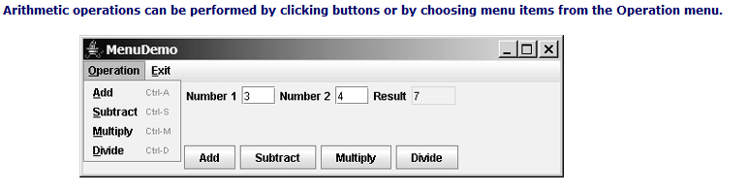
1 import java.awt.*;
2 import java.awt.event.*;
3 import javax.swing.*;
4
5 public class MenuDemo extends JApplet {
6 // Text fields for Number 1, Number 2, and Result
7 private JTextField jtfNum1, jtfNum2, jtfResult;
8
9 // Buttons "Add", "Subtract", "Multiply" and "Divide"
10 private JButton jbtAdd, jbtSub, jbtMul, jbtDiv;
11
12 // Menu items "Add", "Subtract", "Multiply", "Divide" and "Close"
13 private JMenuItem jmiAdd, jmiSub, jmiMul, jmiDiv, jmiClose;
14
15 public MenuDemo() {
16 // Create menu bar
17 JMenuBar jmb = new JMenuBar();

[Page 972]
18
19 // Set menu bar to the applet
20 setJMenuBar(jmb);
21
22 // Add menu "Operation" to menu bar
23 JMenu operationMenu = new JMenu("Operation");
24 operationMenu.setMnemonic('O');
25 jmb.add(operationMenu);
26
27 // Add menu "Exit" to menu bar
28 JMenu exitMenu = new JMenu("Exit");
29 exitMenu.setMnemonic('E');
30 jmb.add(exitMenu);
31
32 // Add menu items with mnemonics to menu "Operation"
33 operationMenu.add(jmiAdd= new JMenuItem("Add", 'A'));
34 operationMenu.add(jmiSub = new JMenuItem("Subtract", 'S'));
35 operationMenu.add(jmiMul = new JMenuItem("Multiply", 'M'));
36 operationMenu.add(jmiDiv = new JMenuItem("Divide", 'D'));
37 exitMenu.add(jmiClose = new JMenuItem("Close", 'C'));
38
39 // Set keyboard accelerators
40 jmiAdd.setAccelerator(
41 KeyStroke.getKeyStroke(KeyEvent.VK_A, ActionEvent.CTRL_MASK));
42 jmiSub.setAccelerator(
43 KeyStroke.getKeyStroke(KeyEvent.VK_S, ActionEvent.CTRL_MASK));
44 jmiMul.setAccelerator(
45 KeyStroke.getKeyStroke(KeyEvent.VK_M, ActionEvent.CTRL_MASK));
46 jmiDiv.setAccelerator(
47 KeyStroke.getKeyStroke(KeyEvent.VK_D, ActionEvent.CTRL_MASK));
48
49 // Panel p1 to hold text fields and labels
50 JPanel p1 = new JPanel(new FlowLayout());
51 p1.add(new JLabel("Number 1"));
52 p1.add(jtfNum1 = new JTextField(3));
53 p1.add(new JLabel("Number 2"));
54 p1.add(jtfNum2 = new JTextField(3));
55 p1.add(new JLabel("Result"));
56 p1.add(jtfResult = new JTextField(4));
57 jtfResult.setEditable(false);
58
59 // Panel p2 to hold buttons
60 JPanel p2 = new JPanel(new FlowLayout());
61 p2.add(jbtAdd = new JButton("Add"));
62 p2.add(jbtSub = new JButton("Subtract"));
63 p2.add(jbtMul = new JButton("Multiply"));
64 p2.add(jbtDiv = new JButton("Divide"));
65
66 // Add panels to the frame
67 setLayout(new BorderLayout());
68 add(p1, BorderLayout.CENTER);
69 add(p2, BorderLayout.SOUTH);
70
71 // Register listeners
72 jbtAdd.addActionListener(new ActionListener() {
73 public void actionPerformed(ActionEvent e) {
74 calculate('+');
75 }
76 });

[Page 973]
77 jbtSub.addActionListener(new ActionListener() {
78 public void actionPerformed(ActionEvent e) {
79 calculate('-');
80 }
81 });
82 jbtMul.addActionListener(new ActionListener() {
83 public void actionPerformed(ActionEvent e) {
84 calculate('*');
85 }
86 });
87 jbtDiv.addActionListener(new ActionListener() {
88 public void actionPerformed(ActionEvent e) {
89 calculate('/');
90 }
91 });
92 jmiAdd.addActionListener(new ActionListener() {
93 public void actionPerformed(ActionEvent e) {
94 calculate('+');
95 }
96 });
97 jmiSub.addActionListener(new ActionListener() {
98 public void actionPerformed(ActionEvent e) {
99 calculate('-');
100 }
101 });
102 jmiMul.addActionListener(new ActionListener() {
103 public void actionPerformed(ActionEvent e) {
104 calculate('*');
105 }
106 });
107 jmiDiv.addActionListener(new ActionListener() {
108 public void actionPerformed(ActionEvent e) {
109 calculate('/');
110 }
111 });
112 jmiClose.addActionListener(new ActionListener() {
113 public void actionPerformed(ActionEvent e) {
114 System.exit(0);
115 }
116 });
117 }
118
119 /** Calculate and show the result in jtfResult */
120 private void calculate(char operator) {
121 // Obtain Number 1 and Number 2
122 int num1 = (Integer.parseInt(jtfNum1.getText().trim()));
123 int num2 = (Integer.parseInt(jtfNum2.getText().trim()));
124 int result = 0;
125
126 // Perform selected operation
127 switch (operator) {
128 case '+': result = num1 + num2;
129 break;
130 case '-': result = num1 - num2;
131 break;
132 case '*': result = num1 * num2;
133 break;
134 case '/': result = num1 / num2;
135 }

[Page 974]
136
137 // Set result in jtfResult
138 jtfResult.setText(String.valueOf(result));
139 }
140 }

Popup Menus
A popup menu, also known as a context menu, is like a regular menu, but does not have a menu bar and can float anywhere on the screen. Creating a popup menu is similar to creating a regular menu. First, you create an instance of JPopupMenu, then you can add JMenuItem, JCheckBoxMenuItem, JRadioButtonMenuItem, and separators to the popup menu. For example, the following code creates a JPopupMenu and adds JMenuItems into it:
JPopupMenu jPopupMenu = new JPopupMenu();
jPopupMenu.add(new JMenuItem("New"));
jPopupMenu.add(new JMenuItem("Open"));

A regular menu is always attached to a menu bar using the setJMenuBar method, but a popup menu is associated with a parent component and is displayed using the show method in the JPopupMenu class. You specify the parent component and the location of the popup menu, using the coordinate system of the parent like this:
jPopupMenu.show(component, x, y);

The popup menu usually contains the commands for an object. Customarily, you display a popup menu by pointing to the object and clicking a certain mouse button, the so-called popup trigger. Popup triggers are system-dependent. In Windows, the popup menu is displayed when the right-mouse button is released. In Motif, the popup menu is displayed when the third mouse button is pressed and held down.

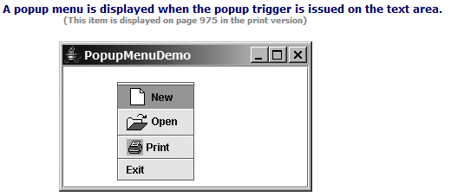
1 import javax.swing.*;
2 import java.awt.*;
3 import java.awt.event.*;
4
5 public class PopupMenuDemo extends JApplet {
6 private JPopupMenu jPopupMenu1 = new JPopupMenu();
7 private JMenuItem jmiNew = new JMenuItem("New",
8 new ImageIcon(getClass().getResource("image/new.gif")));
9 private JMenuItem jmiOpen = new JMenuItem("Open",
10 new ImageIcon(getClass().getResource("image/open.gif")));
11 private JMenuItem jmiPrint = new JMenuItem("Print",
12 new ImageIcon(getClass().getResource("image/print.gif")));
13 private JMenuItem jmiExit = new JMenuItem("Exit");
14 private JTextArea jTextArea1 = new JTextArea();
15
16 public PopupMenuDemo() {
17 jPopupMenu1.add(jmiNew);
18 jPopupMenu1.add(jmiOpen);
19 jPopupMenu1.addSeparator();
20 jPopupMenu1.add(jmiPrint);
21 jPopupMenu1.addSeparator();
22 jPopupMenu1.add(jmiExit);
23 jPopupMenu1.add(jmiExit);
24
25 add(new JScrollPane(jTextArea1), BorderLayout.CENTER);
26
27 jmiNew.addActionListener(new ActionListener() {
28 public void actionPerformed(ActionEvent e) {
29 System.out.println("Process New");
30 }
31 });
32 jmiOpen.addActionListener(new ActionListener() {
33 public void actionPerformed(ActionEvent e) {
34 System.out.println("Process Open");
35 }
36 });
37 jmiPrint.addActionListener(new ActionListener() {
38 public void actionPerformed(ActionEvent e) {
39 System.out.println("Process Print");
40 }

[Page 976]
41 });
42 jmiExit.addActionListener(new ActionListener() {
43 public void actionPerformed(ActionEvent e) {
44 System.exit(0);
45 }
46 });
47 jTextArea1.addMouseListener(new MouseAdapter() {
48 public void mousePressed(MouseEvent e) { // For Motif
49 showPopup(e);
50 }
51
52 public void mouseReleased(MouseEvent e) { // For Windows
53 showPopup(e);
54 }
55 });
56 }
57
58 /** Display popup menu when triggered */
59 private void showPopup(java.awt.event.MouseEvent evt) {
60 if (evt.isPopupTrigger())
61 jPopupMenu1.show(evt.getComponent(), evt.getX(), evt.getY());
62 }
63 }

JToolBar
In user interfaces, a toolbar is often used to hold commands that also appear in the menus. Frequently used commands are placed in a toolbar for quick access. Clicking a command in the toolbar is faster than choosing it from the menu.
Swing provides the JToolBar class as the container to hold tool bar components. JToolBar uses BoxLayout to manage components by default. You can set a different layout manager if desired. The components usually appear as icons. Since icons are not components, they cannot be placed into a tool bar directly. Instead you place buttons into the tool bar and set the icons on the buttons. An instance of JToolBar is like a regular container. Often it is placed in the north, west, or east of a container of BorderLayout.
The following properties in the JToolBar class are often useful:
- orientation specifies whether the items in the tool bar appear horizontally or vertically. The possible values are JToolBar.HORIZONTAL and JToolBar.VERTICAL. The default value is JToolBar.HORIZONTAL.
- floatable is a boolean value that specifies whether the tool bar can be floated. By default, a tool bar is floatable.
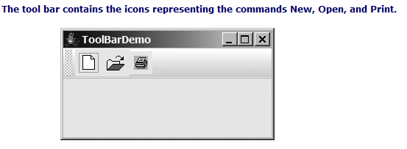
import javax.swing.*;
2 import java.awt.*;
3
4 public class ToolBarDemo extends JApplet {
5 private JButton jbtNew = new JButton(
6 new ImageIcon(getClass().getResource("image/new.gif")));
7 private JButton jbtOpen = new JButton(
8 new ImageIcon(getClass().getResource("image/open.gif")));
9 private JButton jbPrint = new JButton(
10 new ImageIcon(getClass().getResource("image/print.gif")));
11
12 public ToolBarDemo() {
13 JToolBar jToolBar1 = new JToolBar("My Tool Bar");
14 jToolBar1.setFloatable(true);
15 jToolBar1.add(jbtNew);
16 jToolBar1.add(jbtOpen);
17 jToolBar1.add(jbPrint);
18
19 jbtNew.setToolTipText("New");
20 jbtOpen.setToolTipText("Open");
21 jbPrint.setToolTipText("Print");
22
23 jbtNew.setBorderPainted(false);
24 jbtOpen.setBorderPainted(false);
25 jbPrint.setBorderPainted(false);
26
27 add(jToolBar1, BorderLayout.NORTH);
28 }
29 }

JOptionPane Dialogs
You have used JOptionPane to create input and output dialog boxes. This section provides a comprehensive introduction to JOptionPane and other dialog boxes. A dialog box is normally used as a temporary window to receive additional information from the user or to provide notification that some event has occurred. Java provides the JOptionPane class, which can be used to create standard dialogs. You can also build custom dialogs by extending the JDialog class.
The JOptionPane class can be used to create four kinds of standard dialogs:
- Message dialog shows a message and waits for the user to click OK.
- Confirmation dialog shows a question and asks for confirmation, such as OK or Cancel.
- Input dialog shows a question and gets the user's input from a text field, combo box, or list.
- Option dialog shows a question and gets the user's answer from a set of options.
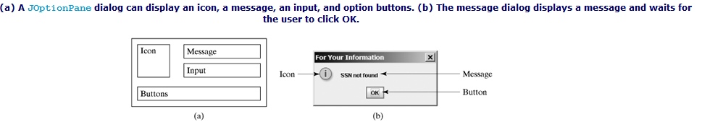
JOptionPane.showMessageDialog(null, "SSN not found",
"For Your Information", JOptionPane.INFORMATION_MESSAGE);

Message Dialogs
A message dialog box displays a message that alerts the user and waits for the user to click the OK button to close the dialog. The methods for creating message dialogs are:
public static void showMessageDialog(Component parentComponent,
Object message)
public static void showMessageDialog(Component parentComponent,
Object message,
String title,
int messageType)
public static void showMessageDialog(Component parentComponent,
Object message,
String title,
int messageType,
Icon icon)

The parentComponent can be any component or null. The message is an object, but often a string is used. These two parameters must always be specified. The title is a string displayed in the title bar of the dialog with the default value "Message".
The messageType is one of the following constants:
JOptionPane.ERROR_MESSAGE
JOptionPane.INFORMATION_MESSAGE
JOptionPane.PLAIN_MESSAGE
JOptionPane.WARNING_MESSAGE
JOptionPane.QUESTION_MESSAGE

By default, messageType is JOptionPane.INFORMATION_MESSAGE.
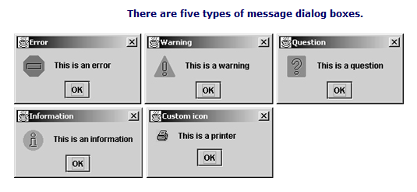

Confirmation Dialogs
A message dialog box displays a message and waits for the user to click the OK button to dismiss the dialog. The message dialog does not return any value. A confirmation dialog asks a question and requires the user to respond with an appropriate button. The confirmation dialog returns a value that corresponds to a selected button.

[Page 984]
The methods for creating confirmation dialogs are:
public static int showConfirmDialog(Component parentComponent,
Object message)
public static int showConfirmDialog(Component parentComponent,
Object message,
String title,
int optionType)
public static int showConfirmDialog(Component parentComponent,
Object message,
String title,
int optionType,
int messageType)
public static int showConfirmDialog(Component parentComponent,
Object message,
String title,
int optionType,
int messageType,
Icon icon)

The parameters parentComponent, message, title, icon, and messageType are the same as in the showMessageDialog method. The default value for title is "Select an Option" and for messageType is QUESTION_MESSAGE. The optionType determines which buttons are displayed in the dialog. The possible values are:
JOptionPane.YES_NO_OPTION
JOptionPane.YES_NO_CANCEL_OPTION
JOptionPane.OK_CANCEL_OPTION

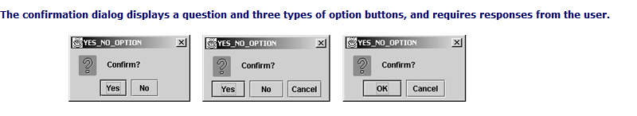
The showConfirmDialog method returns one of the following int values corresponding to the selected option:
JOptionPane.YES_OPTION
JOptionPane.NO_OPTION

[Page 985]
JOptionPane.CANCEL_OPTION
JOptionPane.OK_OPTION
JOptionPane.CLOSED_OPTION

These options correspond to the button that was activated, except for the CLOSED_OPTION, which implies that the dialog box is closed without buttons activated.

Input Dialogs
An input dialog box is used to receive input from the user. The input can be entered from a text field or selected from a combo box or a list. Selectable values can be specified in an array, and one of them can be designated as the initial selected value. If no selectable value is specified when an input dialog is created, a text field is used for entering input. If fewer than twenty selection values are specified, a combo box is displayed in the input dialog. If twenty or more selection values are specified, a list is used in the input dialog.
The methods for creating input dialogs are shown below:
public static String showInputDialog(Object message)
public static String showInputDialog(Component parentComponent,
Object message)
public static String showInputDialog(Component parentComponent,
Object message,
String title,
int messageType)
public static Object showInputDialog(Component parentComponent,
Object message,
int messageType,
Icon icon,
Object[] selectionValues,
Object initialSelectionValue)
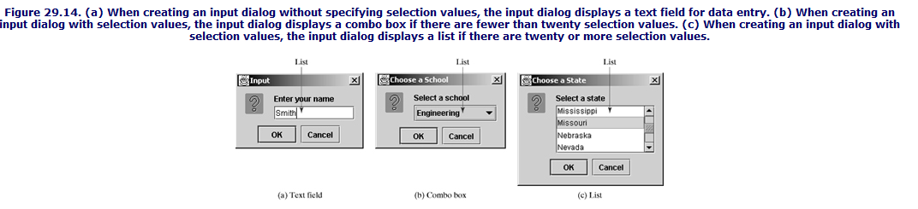

Event-Driven Programming

